Style Guide – PowerForm

Contents
Document Version Control 1
Other References 1
Overview 2
Style Guide 2
Style Guide in Table Format 3

Document Version Control
Version | Description of Changes | Author | Date
1.0 | Initial Draft | S Jasper | 14/06/2023
1.1 | Updated template | J Choi | 30/06/2023
1.2 | Updated font size | J Choi | 01/08/2023
1.3 | Updated label font size | S Jasper | 02/08/2023
1.4 | Updated RGB for Form Heading (Blue) | S Jasper | 11/08/2023
1.5 | Added reference text | J Choi | 04/04/2024
1.6 | Updated Eastern Health Brand Guidelines link to SharePoint | J Choi | 10/10/2024

Other References
Reference | Location
Eastern Health Brand Guidelines | Reference 1 Hyperlink

Overview
The style guide outlines the recommended format to follow to ensure consistency across Eastern Health.

NOTE | In some cases, you may need to deviate from the style guide if required by clinicians to better support a particular workflow

The style guide outlines the following:
- Heading box colour, size and position.
- Heading font, font colour and font size.
- Label font, font colour and font size.
- Instructional text font, font colour and font size.

Excluded from style guide:
- Spacing and formatting between objects: the content of the form should dictate spacing to minimise scrolling where possible.
- Naming convention: naming should be based on clinical input and align with future state design.

Style Guide
Position
Left: 5
Top: 5
Width: 850
Height: 35
Font: 14 Verdana, Bold, White
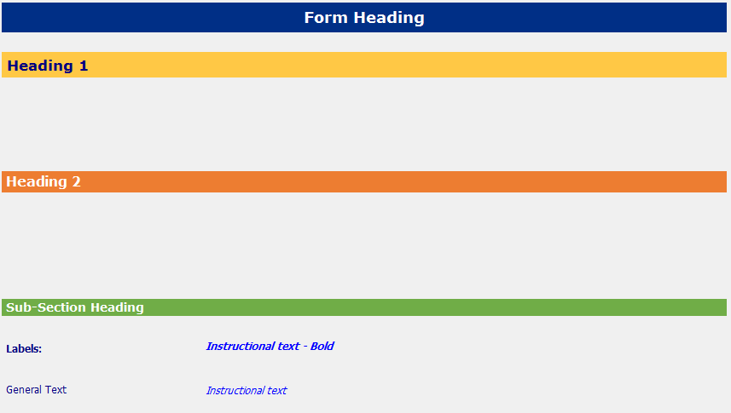
Colour: Blue
R: 0
G: 48
B: 135

Colour: Yellow
R: 255
G: 200
B: 69
Font: 13 Verdana, Bold, Navy
Position
Left: 5
Width: 850
Height: 30

Font: 12 Verdana, Bold, White
Position
Left: 5
Width: 850
Height: 25
Colour: Orange
R: 237
G: 125
B: 49

Position
Left: 5
Width: 850
Height: 20
Font: 11 Verdana, Bold, White
Colour: Green
R: 112
G: 173
B: 71
Form Font Options (Position – Left: 10):
Labels 10 Tahoma, Bold, Navy
General Text 10 Tahoma, Regular, Navy
Instructional Text – Bold 9 Tahoma, Bold Oblique, Blue
Instructional Text 9 Tahoma, Oblique, Blue

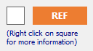
Reference Text Icon
Position Width: 75, Height: 25
Font 10 Tahoma, Bold, White
Back Colour R: 237, G: 125, B: 49

Reference Text Box
Position
Width: 25
Height: 25

Reference Text “Right click on square for more information”
Font 8 Tahoma, Regular, Navy
Position Width: 100, Height: 25

NOTE | Add a space before Heading 1, Heading 2 and Sub-Section Heading e.g. Heading 1  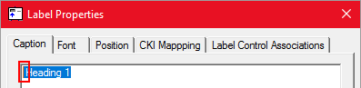

Style Guide in Table Format
Below is the style guide above, but in a table format for easier viewing.

Control | Font | Position | Background Colour
Form Heading | 14 Verdana, Bold, White | Left: 5  Top: 5  Width: 850  Height: 35 | R: 0  G: 48  B: 135
Heading 1 | 13 Verdana, Bold, Navy | Left: 5  Width: 850  Height: 30 | R: 255  G: 200  B: 69
Heading 2 | 12 Verdana, Bold, White | Left: 5  Width: 850  Height: 25 | R: 237  G: 125  B: 49
Sub-Section Heading | 11 Verdana, Bold, White | Left: 5  Width: 850  Height: 20 | R: 112  G: 173  B: 71
Labels | 10 Tahoma, Bold, Navy | Left: 10 | N/A
General Text | 10 Tahoma, Regular, Navy | Left: 10 | N/A
Instructional Text – Bold | 9 Tahoma, Bold Oblique, Blue | Left: 10 | N/A
Instructional Text | 9 Tahoma, Oblique, Blue | Left: 10 | N/A
Reference Text Box | N/A | Width: 25  Height: 25 | N/A
Reference Text Icon | 10 Tahoma, Bold, White | Width: 75  Height: 25 | R: 237  G: 125  B: 49
Reference Text “Right click on square for more information” | 8 Tahoma, Regular, Navy | Width: 100  Height: 25 | N/A

